9. Picture Boxes, Arrays


Review and Preview

In the last class, we introduced the panel control and ways to draw colored lines in a Visual Basic Express project. We continue looking at graphics in this class. The picture box control is studied. In particular, we use that control to display graphics files – photos, drawing, pictures. In our BASIC lesson, we look at a new way to declare variables and ways to count and loop. And, as a project, we build a version of the card game War.

Picture Box Control

Many times in projects, you want to display pictures or drawings saved as a graphics file on your computer. Maybe you have a little kid’s program where if you type an A, an apple appears, B, a ball, and so on. Maybe you want to show a map of the United States (or some other country) for a geography lesson. Maybe you want to see some of the photos you took using a digital camera. The picture box is the control for that use. The picture box is selected from the toolbox. It appears as:

In Toolbox: On Form (default properties):
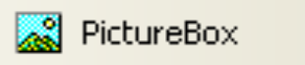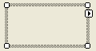

Properties

The picture box control properties are:

Property Description
Name Name used to identify picture box control. Three letter prefix for picture box names is pic.
Image Establishes the graphics file to display in the picture box.
SizeMode Indicates how the image is displayed.
BorderStyle Determines type of picture box border.
Left Distance from left side of form to left side of picture box (X in properties window).
Top Distance from top side of form to top side of picture box (Y in properties window).
Width Width of the picture box in pixels.
Height Height of picture box in pixels.
Enabled Determines whether picture box can respond to user events (in run mode).
Visible Determines whether the picture box appears on the form (in run mode).

The Image property is used to select the graphic file to display in the picture box and the SizeMode property affects how the file is displayed. Let’s look at both properties.

Image Property

The picture box Image property specifies the graphics file to display. To set the Image property at design time, simply display the Properties window for the picture box control and select the Image property. An ellipsis (…) will appear. Click the ellipsis and a Select Resource window will appear. Select Import and an Open File dialog box will appear. Use that box to locate the graphics file to display. The picture box can display pictures stored in several different graphics formats. The formats we study are:

Bitmap A bitmap is an image represented by pixels (screen dots) and stored as a collection of bits in which each bit corresponds to one pixel. It usually has a bmp extension. You can also display icon files (ico extension) since they are essentially bitmap files.

GIF A GIF (Graphic Interchange Format, pronounce ‘jif’ like the peanut butter) file is a compressed bitmap format originally developed by the Internet provider CompuServe. Most graphics you see on the Internet are GIF files. A GIF file has a gif extension.

JPEG A JPEG (Joint Photographic Experts Group, pronounced ‘jay-peg’) file is a compressed bitmap format that is popular on the Internet and is the format usually used to store digital photographs. A JPEG file has a jpg extension.

These are standard graphics file types and there are other types that can be displayed. There are many programs (Paint Shop Pro by JASC, Eden Prairie, Minnesota is a good one) available that will convert a file from one type to another that you may find useful.

A good place to find sample Bitmap and GIF files is on the Internet. To save a displayed Internet graphic as a file, right-click the graphic and choose the Save Picture As option (make sure it has a bmp or gif extension). If you have a digital camera, you probably have hundreds of JPEG files.

In the \BeginVBE\BVBE Projects\Graphics folder, we have included one file of each type for use with our examples:

ball.bmp Bitmap picture of a ball
kidware.gif GIF file with the logo our company (KIDware) uses on its website
mexico.jpg Digital picture from a Mexican vacation

Example

Start Visual Basic Express and start a new project. Place a picture box control on the form. Make it fairly large. Click the Image property and the ellipsis (...) button that appears. A Select Resource window will appear. Make sure the Project resource file radio button is selected and click the button marked Import and a file open window will appear. Move (as shown) to the \BeginVBE\BVBE Projects\Graphics folder and you will see our sample files listed:

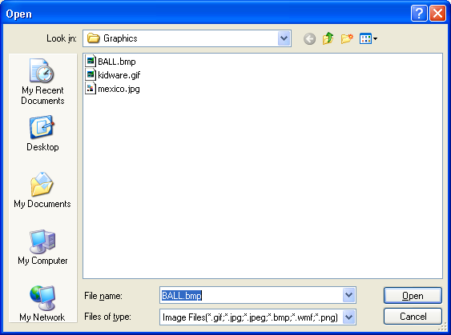

Note six file types are displayed including bitmaps, gifs, and jpegs. Other file types include metafiles (wmf extensions) and portable network graphics (png extension) – you might like to learn about these other file types on your own. One type not displayed is icon files (ico extension). To see these files, which will display just fine, you need to click Files of type and choose All Files.
Choose the ball bitmap file and click Open. You will be returned to the Select Resource window and it should look like this:

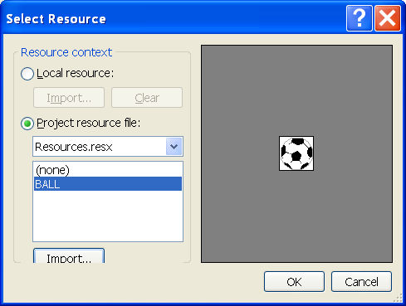

Click the OK button.
On your form, you should see something like this (depending on the size of your picture box):

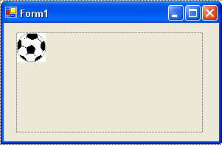

The image is in the upper left hand corner of the picture box. It appears in full-size.

Return to the properties window and choose the kidware logo gif file for the picture box Image property (following the same procedure using the Select Resource window):

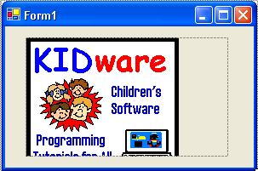

In this example, the picture box is shorter than the graphic, so the picture is vertically “cropped.” It is located in the upper left hand corner and appears in full-size. If the picture is cropped in your example too, you can resize the picture box control to see the entire graphic.

Lastly, load and view the mexico JPEG file:

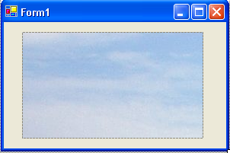

There’s not much to see here. The picture box is smaller than the photo, so only the sky is seen. The picture appears in full-size and is seriously cropped.

We see that the bitmap file seems to display satisfactorily. The GIF and JPEG files had cropping problems though. The SizeMode property of the picture box control gives us some control on how we want a graphic to display. This will help us solve some of the problems we’ve seen. We look at that property next, but first a quick look at how to remove a graphic from a picture box.

There are times you may want to delete the graphic displayed in a picture box. To do this, click Image in the properties window. In the right side of the window will be the current file (with a very tiny copy of the graphic). Select this information (double-click to highlight it) and press the keyboard Del key. The displayed picture will vanish and the property will read (None).

SizeMode Property

The SizeMode property dictates how a particular image will be displayed in a picture box. There are five possible values for this property: Normal, CenterImage, StretchImage, AutoSize, Zoom. The effect of each value is:

SizeMode Effect
Normal Image appears in original size. If picture box is larger than image, there will be blank space. If picture box is smaller than image, the image will be cropped.
CenterImage Image appears in original size, centered in picture box. If picture box is larger than image, there will be blank space. If picture box is smaller than image, image is cropped.
StretchImage Image will ‘fill’ picture box. If image is smaller than picture box, it will expand. If image is larger than picture box, it will scale down. Bitmap files do not scale nicely. JPEG and GIF files do scale nicely.
AutoSize Reverse of StretchImage - picture box will change its dimensions to match the original size of the image. Be forewarned – some files are very large!
Zoom Similar to StretchImage. The image will adjust to fit within the picture box, however its actual height to width ratio is maintained.

In the previous example, the SizeMode property had its default value of Normal, so all the images appeared in their original size. In the case of the bitmap file, there was lots of blank space. With the GIF and JPEG files, there was cropping. Similar results would have been seen with the SizeMode property changed to CenterImage. The most useful (in my opinion) of the SizeMode property choices is StretchImage. With this property, the image always fills the space you give it.

Example

Continue the previous project. Change the SizeMode property of the picture box control to CenterImage. Reload each of the three sample graphics files. Note when you click the ellipsis next to Image in the picture box properties window, the Select Resources window will appear as:

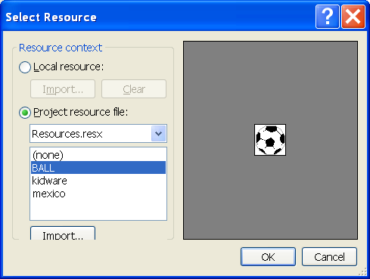

Since each graphic already appears in the Select Resource window (these graphics have become part of the project), there is no need to reload the actual graphics files. You can choose the Image property directly from this window. The process is – select the desired graphic (resource) and click OK.

With the CenterImage SizeMode property, note the difference in how the files are displayed. In particular, the GIF and JPEG files are still cropped, but now they’re centered in the control. For example, here is the kidware logo graphic with the image centered:

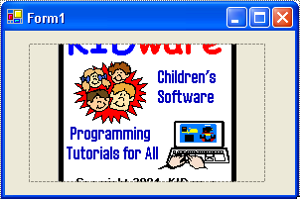

Change the SizeMode to StretchImage. Reload each of the sample graphics files. Notice how the graphic takes up the entire picture box. Here’s the mexico graphic:

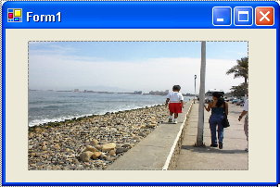

Try resizing the picture box control. How do the different graphics types resize? After resizing the picture box control, does the picture still look recognizable? You should find that bitmaps (in most cases) scale poorly, while GIF and JPEG graphics scale very nicely. Change the SizeMode to Zoom. Notice the graphic displays are very similar to those seen with StretchImage. The mexico graphic appears clearer, since the height to width ratio are correct:

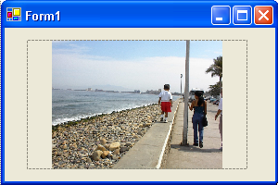
Lastly, change the SizeMode to AutoSize. Load each graphic example and see the results. Watch out! The Mexico photo is very large. AutoSize should only be used when you know the size of your images and you allow for that size on your project form. If you like, try finding other graphic files on your computer and view them in the picture box with different SizeMode properties.

Events

The picture box control supports a few events. The important ones are:

Event Description
Click Event executed when user clicks on picture box.
MouseDown Event executed when user presses mouse button while cursor is over picture box.
MouseMove Event executed when user moves cursor over picture box.
MouseUp Event executed when user releases mouse button while cursor is over picture box.

You would use the Click event when you are choosing from a group of picture box controls in a multiple choice environment. You would use the mouse events when you need to know which mouse button was pressed or released and/or where the cursor was when a mouse click, move, or release occurred.

Typical Use of Picture Box Control

The usual design steps to use a picture box control for displaying a graphic file are:

- Set the Name and SizeMode property (most often, StretchImage).
- Set Image property, either in design mode or at run-time.
BASIC - The Sixth Lesson

In this BASIC lesson, we look at ways to store large numbers of variables, a technique for counting, and some code for shuffling a deck of cards (or randomly sorting a list of numbers).

Variable Arrays

The local school principal has recognized your great Visual Basic Express programming skills and has come for your help. Everyone (300 students) in the school has just taken a basic skills test. The principal wants you to write a program that stores each student’s name and score. The program should rank (put in order) the scores and compute the average score. The code to do this is not that hard. The problem we want to discuss here is how do we declare all the variables we need? To write this test score program, you need 300 string variables to store student names and 300 integer variables to store student scores. We are required to declare every variable we use in the code window general declarations area. Do you want to type 600 lines of code something like this?:

Dim Student1 As String
Dim Student2 As String
Dim Student3 As String
.
.
Dim Student300 As String
Dim Score1 As Integer
Dim Score2 As Integer
Dim Score3 As Integer
.
.
Dim Score300 As Integer

I don’t think so.
BASIC provides a way to store a large number of variables under the same name - variable arrays. Each variable in an array, called an element, must have the same data type, and they are distinguished from each other by an array index. A variable array is declared in a way similar to other variables. The Dim (actually the origin of the Dim statement is related to arrays - Dim stands for dimension) statement is used. For 300 student names and 300 student scores, we write:

Dim Student(300) As String
Dim Score(300) As Integer

The number in parentheses is called the array dimension. These two lines have the same effect as the 600 declaration lines we might have had to write! And, notice how easy it would be to add 200 more variables if we needed them.

We now have 300 Student variables and 300 Score variables available for our use. Well, we actually have 301 of each variable! How is this? BASIC array indices begin with 0 and end at the dimension value, in this case 300. That yields 301 array elements. In this class, we will ignore the 0th element. As you progress as a Visual Basic Express programmer, you will not be able to ignore this 0th element. So, remember it exists.

Each variable in an array is referred to by its declared name and index. For example, to assign the 150th student’s information, we could write two lines of code like this:

Student(150) = “Billy Gates”
Score(150) = 100

Array variables can be used anywhere regular variables are used. They can be used on the left side of assignment statements or in expressions. To add up the first three test scores, you would write:

Sum = Score(1) + Score(2) + Score(3)

We still need to provide values for each element in each array, but there are also some shortcuts we can take to avoid lots of assignment statements. You will find variable arrays are very useful when working with large numbers (and sometimes, not so large numbers) of similar variables.

For/Next Loops

A common computer programming task is counting. We might like to execute some BASIC code segment a particular number of times - we would need to count how many times we executed the code. In the school score example from above, we need to go through all 300 scores to compute an average. BASIC offers a convenient way to do counting: the For/Next loop.

A For/Next loop has this structure:

For LoopCounter = StartValue To EndValue Step Increment
[BASIC code to execute goes here]
Next LoopCounter

The For statement creates a loop (place where code is repeated) in which the variable LoopCounter (called the loop index) is initialized at StartValue and is then incremented (changed) by Increment each time the program executes the loop. The words “Step Increment” are optional. If they are omitted, an increment (Step) of one is assumed. The end of the loop is marked by the Next statement. The loop is repeated until LoopCounter reaches or exceeds EndValue. When the loop is completed, program execution continues after the Next statement. Each For statement in your BASIC program must have a matching Next statement (the Intellisense feature of Visual Basic Express will automatically add a Next statement as soon as you type a For statement). The code between the For and Next should be indented (automatically done by the Visual Basic Express environment). For/Next loops can be nested (one loop in another), but that’s beyond this class.

Let’s look at a few For/Next examples to see how they work. This loop will repeat 10 times:

For LoopCounter = 1 to 10
[BASIC code to execute goes here]
Next LoopCounter

LoopCounter has a value of 1 the first time through loop, 2 the second time through, and repeats until LoopCounter has a value of 10 the final time through. How about a rocket launch countdown? This loop will do the job:

For LoopCounter = 10 to 1 Step -1
[BASIC code to execute goes here]
Next LoopCounter

Here LoopCounter starts at 10 and goes down by 1 (Step -1) each time the loop is repeated. Yes, you can have negative Step values. And, you can have increments that are not 1. This loop counts from 0 to 200 by 5’s:

For LoopCounter = 0 to 200 Step 5
[BASIC code to execute goes here]
Next LoopCounter

How about averaging the scores from our student example. This code will do the job:

ScoreSum = 0
For StudentNumber = 1 to 300
ScoreSum = ScoreSum + Score(StudentNumber)
Next StudentNumber
Average = ScoreSum / 300

To find an average of a group of numbers, you add up all the numbers then divide by the number of numbers you have. In this code, ScoreSum represents the sum of all the numbers. We set this to zero to start. Then, each time through the loop, we add the next score to that “running“ sum. The loop adds up all 300 scores making use of the Score array. The first time through it adds in Score(1), then Score(2), then Score(3), and so on, until it finishes by adding in Score(300). Once done, the Average is computed by dividing ScoreSum by 300. Do you see how the For/Next loop greatly simplifies the task of adding up 300 numbers? This is one of the shortcut methods we can use when working with arrays. Study each of these examples so you have an idea of how the For/Next loop works. Use them when you need to count.

Procedure Level Variables

Before continuing, let’s address an important issue. Notice, at a minimum, the For/Next loop requires the declaration of one variable, the loop index, usually an integer variable. This variable is only used in this loop - it’s value is of no use outside of the event procedure it is used in. When we declare a variable in the general declarations area of the code window, its value is available to all event procedures. Such declarations are not necessary with For/Next loop indexes and it becomes a headache if you have lots of For/Next loops. Loop indexes and other variables not needed outside of a particular procedure can be declared within the procedure. We give these variables procedure level scope - their value is only known within that procedure. Variables declared in the general declarations area are said to have form level scope. Variables are given procedure level scope using the same Dim statement. Just declare any procedure level variables right after the event procedure header line.

As an example of declaring procedure level variables, assume we have a button control (named btnAverage) on a form that computes the student average score in our example. The btnAverage_Click event procedure would look like this:

Private Sub btnAverage_Click(ByVal sender As System.Object, ByVal e As System.EventArgs) Handles btnAverage.Click
Dim ScoreSum As Integer
Dim StudentNumber As Integer
ScoreSum = 0
For StudentNumber =1 to 300
ScoreSum = ScoreSum + Score(StudentNumber)
Next StudentNumber
Average = ScoreSum / 300
End Sub

In this example, ScoreSum and StudentNumber are only used and needed in this procedure, hence are declared as procedure level variables. The variable Average should be declared in the general declarations area so it has form level scope and is available everywhere in your project. As you write BASIC code, decide whether you want your variables to have procedure level or form level scope and declare them in the proper area in the code window.

Shuffle Routine

A common task in any computer program is to randomly sort a list of consecutive integer values. Why would you want to do this? Say you have four answers in a multiple choice quiz. Randomly sort the integers 1, 2, 3, and 4, so the answers are presented in random order. Or, you have a quiz with 30 questions. Randomly sort the questions for printing out as a worksheet. Or, the classic application is shuffling a deck of standard playing cards (there are 52 cards in such a deck). In that case, you randomly sort the integers from 1 to 52 to “simulate” the shuffling process. Let’s build a shuffle routine using the variable array and For/Next knowledge we now have. We call it a shuffle routine, recognizing it can do more than shuffle a card deck. Our routine will sort any number of consecutive integers.

Usually when we need a computer version of something we can do without a computer, it is fairly easy to write down the steps taken and duplicate them in BASIC code. Remember we did that with the Sandwich Maker project in Class 7. When we shuffle a deck of cards, we separate the deck in two parts, then interleaf the cards as we fan each part, making that familiar shuffling noise. I don’t know how you could write BASIC code to do this. Other times, the computer version of a process is easy to do on a computer, but hard or tedious to do off the computer. Our shuffle routine is an example of such a process.

We will perform what could be called a “one card shuffle.” In a one card shuffle, you pull a single card (at random) out of the deck and lay it aside on a pile. Repeat this 52 times and the cards are shuffled. Try it! I think you see this idea is simple, but doing a one card shuffle with a real deck of cards would be awfully time-consuming. We’ll use the idea of a one card shuffle here, with a slight twist. Rather than lay the selected card on a pile, we will swap it with the bottom card in the stack of cards remaining to be shuffled. This takes the selected card out of the deck and replaces it with the remaining bottom card. The result is the same as if we lay it aside.

Here’s how the shuffle works with N numbers:

- Start with a list of N consecutive integers.
- Randomly pick one item from the list. Swap that item with the last item. You now have one fewer items in the list to be sorted (called the remaining list), or N is now N - 1.
- Randomly pick one item from the remaining list. Swap it with the item on the bottom of the remaining list. Again, your remaining list now has one fewer items.
- Repeatedly remove one item from the remaining list and swap it with the item on the bottom of the remaining list until you have run out of items. When done, the list will have been replaced with the original list in random order.

Confusing? Let’s show a simple example with N = 5 (a very small deck of cards).

The starting list is (with 5 remaining items):

1 2 3 4 5
Remaining List

We want to pick one item, at random, from this list. Using the BASIC random number generator, we would choose a random number from 1 to 5. Say it was 3. We take the third item in the list (the 3) and swap it with the last item in the list (the 5). We now have:

1 2 5 4 3
Remaining List

There are now 4 items in the remaining list. Pick a random number from 1 to 4 - say it’s 4. The fourth item in the remaining list is 4. Swap it with the last item in the remaining list. Wait a minute! The last item in the remaining list is the 4. In this case, we swap it with itself, or it stays put. If the random number was something other than 4, there really would have been a swap here. We now have:

1 2 5 4 3
Remaining List

There are 3 items in the remaining list. Pick a random number from 1 to 3 - say it’s 1. The first item in the list is 1. Swap the 1 with the last item in the remaining list (the 5), giving us:

5 2 1 4 3
Remaining List

There are 2 items in the remaining list. Pick a random number from 1 to 2 - say it’s 1. The first item in the list is 5. Swap the 5 with the last item in the remaining list (the 2), giving us the final result, the numbers 1 to 5 randomly sorted:

2 5 1 4 3

Pretty neat how this works, huh?

We want to describe the one card shuffle with BASIC code. Most of the code is straightforward. The only question is how to do the swap involved in each step. This swap is easy on paper. How do we do a swap in BASIC? Actually, this is a common BASIC task and is relatively simple. At first thought, to swap variable A with variable B, you might write:

A = B
B = A

The problem with this code is that when you replace A with B in the first statement, you have destroyed the original value of A. The second statement just puts the newly assigned A value (B) back in B. Both A and B now have the original B value! Actually, swapping two variables is a three step process. First, put A in a temporary storage variable (make it the same type as A and B and give it procedure level scope). Then, replace A by B. Then, replace B by the temporary variable (which holds the original A value). If T is the temporary variable, a swap of A and B is done using:

T = A
A = B
B = T

You use swaps like this in all kinds of Visual Basic Express applications.

Now, we’ll see the BASIC code that uses a one card shuffle to randomly sort N consecutive integer values. When done the random list of integers is in the array NumberList, which should be declared in the general declarations area of your project with the proper dimension. Also declare the variable, NumberOfItems, which is the length of the list. For a deck of cards, these declarations would be:

Dim NumberList(52) As Integer
Dim NumberOfItems As Integer

You need to make sure to assign a value (52) to NumberOfItems somewhere, most likely in the form Load procedure. All other variables can be given procedure level scope. These variables are:

TempValue - temporary integer variable used for swapping
LoopCounter - integer loop counter variable
ItemPicked - integer variable giving item picked in remaining list
Remaining - integer loop variable giving number of items in remaining list

We also need a random number object (MyRandom) with procedure level scope to do all the random number generation.
The code is:

'Variable declarations (put at top of procedure)

Dim TempValue As Integer
Dim LoopCounter As Integer
Dim ItemPicked As Integer
Dim Remaining As Integer
Dim MyRandom As New Random

'One card shuffle code
'Initialize NumberList
For LoopCounter = 1 to NumberOfItems
NumberList(LoopCounter) = LoopCounter
Next LoopCounter
'Work through Remaining values
'Start at NumberOfItems and swap one value
'at each For/Next loop step
'After each step, Remaining is decreased by 1
For Remaining = NumberOfItems to 2 Step -1
'Pick item at random
ItemPicked = MyRandom.Next(Remaining) + 1
'Swap picked item with bottom item
TempValue = NumberList(Remaining)
NumberList(Remaining) = NumberList(ItemPicked)
NumberList(ItemPicked) = TempValue
Next Remaining

Study this code and see how it implements the procedure followed in the simple five number example. It’s not that hard to see. Understanding how such code works is a first step to becoming a good BASIC programmer. Notice this bit of code uses everything we talked about in this class’ BASIC lesson: arrays, For/Next Loops, and procedure level variables.
Project - Card Wars

In this project, we create a simplified version of the kid’s card game - War. You play against the computer. You each get half a deck of cards (26 cards). Each player turns over one card at a time. The one with the higher card wins the other player’s card. The one with the most cards at the end wins. Obviously, the shuffle routine will come in handy here. We call this project Card Wars! This project is saved as CardWars in the projects folder (\BeginVBE\BVBE Projects).

Project Design

We will use a panel control to represent the outline of each player’s card. A label control will show the card’s value and a picture box control will display the card’s suit (hearts, diamonds, clubs, spades). A button will control starting a new game or drawing a new card, depending on game state. Another button will control stopping the game, if playing, or stopping the program, if not playing. The current score (number of cards each player has) will be displayed in a labeled text box control.

Place Controls on Form

Start a new project in Visual Basic Express. Place two panel controls on the form. Size them to represent the two displayed cards. Place a label and picture box control in each panel. Add two buttons to the form. Add two labels and two text boxes that will be used for the scoring system. Add a large text box to tell us when the game is over. And, add four more picture boxes that will be used to hold the images for each card suit. When done, my form looks like this:
PictureBox1
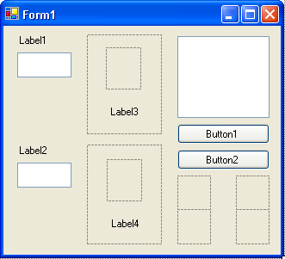
PictureBox2
PictureBox3 – PictureBox6
Panel1
Panel2
TextBox1
TextBox2
TextBox3

Set Control Properties

Set the control properties using the properties window:

Form1 Form:
Property Name Property Value
Text Card Wars
FormBorderStyle Fixed Single
StartPosition CenterScreen

Panel1 Panel:
Property Name Property Value
Name pnlPlayer
BackColor White
BorderStyle FixedSingle

Panel2Panel:
Property Name Property Value
Name pnlComputer
BackColor White
BorderStyle FixedSingle

Picture Box1 Picture Box:
Property Name Property Value
Name picPlayer
SizeMode StretchImage

Picture Box2 Picture Box:
Property Name Property Value
Name picComputer
SizeMode StretchImage

PictureBox3 Picture Box:
Property Name Property Value
Name picHeart
Image Heart.ico (in \BeginVBE\BVBE Projects\CardWars folder)
SizeMode AutoSize
Visible False

PictureBox4 Picture Box:
Property Name Property Value
Name picDiamond
Image Diamond.ico (in \BeginVBE\BVBE Projects\CardWars folder)
SizeMode AutoSize
Visible False

PictureBox5 Picture Box:
Property Name Property Value
Name picClub
Image Club.ico (in in \BeginVBE\BVBE Projects\CardWars folder)
SizeMode AutoSize
Visible False

PictureBox6 Picture Box:
Property Name Property Value
Name picSpade
Image Spade.ico (in in \BeginVBE\BVBE Projects\CardWars folder)
SizeMode AutoSize
Visible False

The Visible properties for these four picture box controls (picHeart, picDiamond, picClub, picSpade) are purposely False. We don’t want them to show up on the form in run mode - we just want to use their stored picture for our card displays. This is done a lot in Visual Basic Express. When setting the Image property, in the Open File Dialog, you will need to make sure you view All Files and not just the Image Files. Icon files will not appear unless you make this change.

Label1 Label:
Property Name Property Value
Name lblYou
Text You
Font Size 10
TextAlign LeftCenter

TextBox1 Text Box:
Property Name Property Value
Name txtYouScore
Text 0
Font Size 12
Font Style Bold
ReadOnly True
TextAlign Center
BackColor White

Label2 Label:
Property Name Property Value
Name lblComp
Text Computer
Font Size 10
TextAlign LeftCenter

TextBox2 Text Box:
Property Name Property Value
Name txtCompScore
Text 0
Font Size 12
Font Style Bold
ReadOnly True
TextAlign Center
BackColor White

Label3 Label:
Property Name Property Value
Name lblPlayer
Text [Blank]
Font Size 18
Font Style Bold
TextAlign MiddleCenter

Label4 Label:
Property Name Property Value
Name lblComputer
Text [Blank]
Font Size 18
Font Style Bold
TextAlign MiddleCenter

TextBox3 Text Box:
Property Name Property Value
Name txtOver
Text Game Over
Font Size 14
Font Style Bold
ReadOnly True
TextAlign Center
BackColor White
ForeColor Red

Button1 Button:
Property Name Property Value
Name btnNew
Text New Game

Button2 Button:
Property Name Property Value
Name btnExit
Text Exit

When done, my form looks like this:
lblPlayer
picPlayer
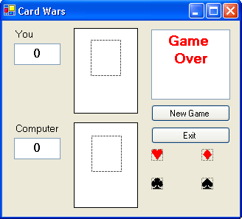
picDiamond
picHeart
picSpade
btnNew
btnExit
pnlPlayer
lblYou
txtYouScore
lblComp
txtCompScore
txtOver
picClub
pnlComputer
picComputer
lblComputer

Write Event Procedures

The idea of this game is quite simple. You click the New Game button to start. This shuffles the cards, resets the scores to zero and changes the button’s Text to Next Card. It also changes the Exit button Text to Stop (for stopping the current game). A card for you (upper card) and a card for the computer (lower card) are displayed. The computer decides which card is higher. The player with the higher card gets two points. If it’s a tie, each player gets one point. Scores are displayed under You (txtYouScore has your score) and Computer (txtCompScore has computer’s score). Click Next Card. A new card is displayed for each player and the scores updated. Continue clicking Next Card until the game is over (each player has shown 26 cards). At that point, the ‘Game Over’ message is displayed and the button captions are reset to their original values. By checking the score, a winner can be determined. You can stop the game early by clicking Stop. There are only two event procedures - one for btnNew_Click and one for btnExit_Click. Before looking at these events, let’s look at needed variables.

We only need two variables (well, really 53, but, arrays help out) for this project. The first is an integer array (CardNumber) that has the 52 shuffled numbers representing each card in the deck. The first half [CardNumber (1) - CardNumber(26)] will be your cards while the second half [CardNumber(27) - CardNumber(52)] will be the computer’s. The second variable is CardIndex, an integer indicating which card to display. Open the code window and declare these variables in the general declarations area:

Dim CardNumber(52) As Integer
Dim CardIndex As Integer

Now, let’s outline the steps involved in the btnNew_Click event. First, we are letting this command button have two purposes. It either starts a new game (Text is New Game) and or gets a new card (Text is Next Card). So, the Click event has two segments. If Text is New Game, the steps are:

- Hide ‘Game Over’ notice
- Set btnNew Text to “Next Card”
- Set btnExit Text to “Stop”
- Set scores to zero
- Shuffle cards
- Initialize CardIndex to one
- Display first card for each player
- Compare cards - update score

If Text is Next Card, the steps are:

- Display two new cards
- Compare displayed cards - update scores
- Increment CardIndex
- If there are no cards left, stop game - display ‘Game Over’ message, change button captions. Otherwise, wait for click on Next Card button.

Most of these steps are easily done now that we know how to shuffle a deck of cards. The only tough part is deciding how to display and compare cards. Let’s look at that in some detail.

Displaying a card consists of answering two questions: what is the card suit and what is the card value? The four suits are hearts, diamonds, clubs, and spades. The thirteen card values, from lowest to highest, are: 2, 3, 4, 5, 6, 7, 8, 9, 10, Jack (J), Queen (Q), King (K), Ace (A). We’ve seen in our shuffle routine that a card number will range from 1 to 52. How do we translate that card number to a card suit and value? (Notice the distinction between card number and card value - card number ranges from 1 to 52, card value can only range from 2 to Ace.) We need to develop some type of translation rule. This is done all the time in BASIC. If the number you compute with or work with does not directly translate to information you need, you need to make up rules to do the translation. For example, the numbers 1 to 12 are used to represent the months of the year. But, these numbers tell us nothing about the names of the month. We need a rule to translate each number to a month name.

We know we need 13 of each card suit. Hence, an easy rule to decide suit is: cards numbered 1 - 13 are hearts, cards numbered 14 - 26 are diamonds, cards numbered 27 - 39 are clubs, and cards numbered 40 - 52 are spades. Suit is represented on the displayed card by the two picture boxes: picPlayer (your card) and picComputer (computer’s card). For card values, lower numbers should represent lower cards. A rule that does this for each number in each card suit is:

Card Numbers
Hearts Diamonds Clubs Spades Card Value
1 14 27 40 2
2 15 28 41 3
3 16 29 42 4
4 17 30 43 5
5 18 31 44 6
6 19 32 45 7
7 20 33 46 8
8 21 34 47 9
9 22 35 48 10
10 23 36 49 J
11 24 37 50 Q
12 25 38 51 K
13 26 39 52 A

As examples, notice card 23 is a Jack of Diamonds. Card 31 is a 6 of Clubs. The card values are displayed in the lblPlayer and lblComputer label controls. We now can display cards. How do we compare them?

Card comparisons must be based on a numerical value, not displayed card value - it’s difficult to check if K is greater than 7, though it can be done. So, one last rule is needed to relate card value to numerical value. It’s a simple one - start with a 2 having a numerical value of 1 (lowest) and go up, with an Ace (A) having a numerical value of 13 (highest). This makes numerical card comparisons easy. Notice hearts card numbers already go from 1 to 13. If we subtract 13 from diamonds numbers, 26 from clubs numbers, and 39 from spades numbers, each of those card numbers will also range from 1 to 13. This gives a common basis for comparing cards. This all may seem complicated, but look at the BASIC code and you’ll see it really isn’t.

The BASIC code that implements the btnNew_Click event procedure is:

Private Sub btnNew_Click(ByVal sender As System.Object, ByVal e As System.EventArgs) Handles btnNew.Click
'Procedure level variables
Dim TempValue As Integer
Dim LoopCounter As Integer
Dim ItemPicked As Integer
Dim Remaining As Integer
Dim MyRandom As New Random
Dim YourNumber As Integer ' Your card number
Dim ComputerNumber As Integer ' Computer card number
If btnNew.Text = "New Game" Then
'New game clicked
txtOver.Visible = False
btnNew.Text = "Next Card"
btnExit.Text = "Stop"
'Zero out scores
txtYouScore.Text = "0"
txtCompScore.Text = "0"
'Shuffle cards using one card shuffle code
'Initialize CardNumbers
For LoopCounter = 1 To 52
CardNumber(LoopCounter) = LoopCounter
Next LoopCounter
'Work through Remaining values
'Start at 52 and swap one value
'at each For/Next loop step
'After each step, Remaining is decreased by 1
For Remaining = 52 To 2 Step -1
'Pick item at random
ItemPicked = MyRandom.Next(Remaining) + 1
'Swap picked item with bottom item
TempValue = CardNumber(Remaining)
CardNumber(Remaining) = CardNumber(ItemPicked)
CardNumber(ItemPicked) = TempValue
Next Remaining
'Set CardIndex to one
CardIndex = 1
End If
'Display cards
'Display your card's suit
'Determine your card's number for comparisons
Select Case CardNumber(CardIndex)
Case 1 To 13
picPlayer.Image = picHeart.Image
YourNumber = CardNumber(CardIndex)
Case 14 To 26
picPlayer.Image = picDiamond.Image
YourNumber = CardNumber(CardIndex) - 13
Case 27 To 39
picPlayer.Image = picClub.Image
YourNumber = CardNumber(CardIndex) - 26
Case 40 To 52
picPlayer.Image = picSpade.Image
YourNumber = CardNumber(CardIndex) - 39
End Select
'Display your card's value
Select Case YourNumber
Case 1 To 9
lblPlayer.Text = Str(YourNumber + 1) + " "
Case 10
lblPlayer.Text = "J"
Case 11
lblPlayer.Text = "Q"
Case 12
lblPlayer.Text = "K"
Case 13
lblPlayer.Text = "A"
End Select
'Display computer's card suit
'Determine computer's number for comparisons
Select Case CardNumber(CardIndex + 26)
Case 1 To 13
picComputer.Image = picHeart.Image
ComputerNumber = CardNumber(CardIndex + 26)
Case 14 To 26
picComputer.Image = picDiamond.Image
ComputerNumber = CardNumber(CardIndex + 26) - 13
Case 27 To 39
picComputer.Image = picClub.Image
ComputerNumber = CardNumber(CardIndex + 26) - 26
Case 40 To 52
picComputer.Image = picSpade.Image
ComputerNumber = CardNumber(CardIndex + 26) - 39
End Select
'Display computer card's value
Select Case ComputerNumber
Case 1 To 9
lblComputer.Text = Str(ComputerNumber + 1) + " "
Case 10
lblComputer.Text = "J"
Case 11
lblComputer.Text = "Q"
Case 12
lblComputer.Text = "K"
Case 13
lblComputer.Text = "A"
End Select
'Compare displayed cards
If YourNumber > ComputerNumber Then
'You win
txtYouScore.Text = Str(Val(txtYouScore.Text) + 2)
ElseIf ComputerNumber > YourNumber Then
'Computer win
txtCompScore.Text = Str(Val(txtCompScore.Text) + 2)
Else
'A Tie!
txtYouScore.Text = Str(Val(txtYouScore.Text) + 1)
txtCompScore.Text = Str(Val(txtCompScore.Text) + 1)
End If
CardIndex = CardIndex + 1
'Check to see if all cards have been used
If CardIndex > 26 Then
'Game over
txtOver.Visible = True
btnNew.Text = "New Game"
btnExit.Text = "Exit"
End If

End Sub

You should be able to see each outlined step in this code. Notice particularly the shuffle routine and how CardIndex is used with the CardNumber array to display your card and the computer card. Remember the computer card is 26 elements ahead of your card in the CardNumber array. Look at how the card numbers are found and how comparisons are made. Check out the tricky way scores are updated without using any variables! Notice, too, how as your programming knowledge expands, there’s a lot more happening in the code we write. Remember to use cut and paste where you can - it will make your work easier.

We now need to code the btnExit_Click event. Like btnNew, It also has two purposes. If the button Text property is Exit, the program stops. If the Text is Stop, the current game stops. That code is pretty simple:

Private Sub btnExit_Click(ByVal sender As System.Object, ByVal e As System.EventArgs) Handles btnExit.Click
If btnExit.Text = "Exit" Then
'Stop program
Me.Close()
Else
'Stop game
txtOver.Visible = True
btnExit.Text = "Exit"
btnNew.Text = "New Game"
End If

End Sub

Save the project by clicking the Save All button in the toolbar.

Run the Project

Run the project. Click New Game to get started. Click Next Card to display each pair of cards. Notice how the different controls are used to make up the cards. Make sure the program works correctly. Here’s what my screen looks like in the middle of a game:

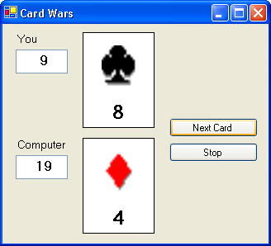

Play through one game and check each comparison to make sure you get the correct result and score with each new card. Make sure the Stop and Exit buttons work properly. Go through the usual process of making sure the program works as it should. Once you’re convinced everything is OK, have fun playing the game. Share your creation with friends. If you made any changes during the running process, make sure you save the project.

Other Things to Try

Possible changes to the Card Wars project are obvious, but not easy. One change would be to have more than two players. Set up three and four player versions. You could also add a message after each comparison to way which player won (or whether it was a tie). You could use the txtOver control that’s already there.

In Card Wars, we stop the game after going through the deck one time. In the real card game of War, after the first round, the players pick up the cards they won, shuffle them, and play another round. Every time a player uses all the cards in their “hand,” they again pick up their winnings pile, reshuffle and continue playing. This continues until one player has lost all of their cards. Another change to Card Wars would be to write code that plays the game with these rules. As we said, it’s not easy. You would need to add code to keep track of which cards each player won, when they ran out of cards to play, how to reshuffle their remaining cards, and new logic to see when a game was over. Such code would use more arrays, more For/Next loops, and more variables. If you want a programming challenge, go for it!

And, while you’re tackling challenges, here’s another. In the usual War game, when two cards have the same value - War is declared! This means each player takes three cards from their “hand” and lays them face down. Then another card is placed face up. The higher card at that time wins all 10 cards! If it’s still a tie, there’s another War. Try adding this logic to the game. You might need to change the display to allow more cards. You’ll need to figure out how to lay cards “face down” in BASIC. You’ll need to check if a player has enough cards to wage War. Another difficult task, but give it a try if you feel adventurous.

Summary

This class presented one of the more challenging projects yet. The code involved in shuffling cards and displaying cards, though straightforward, was quite involved. The use of panel and picture box controls helped in the display. The use of arrays and For/Next loops made the coding a bit easier. If you completely understood the Card Wars project, you are well on your way to being a good Visual Basic Express programmer. Now, on to the last class.

This page intentionally not left blank.

